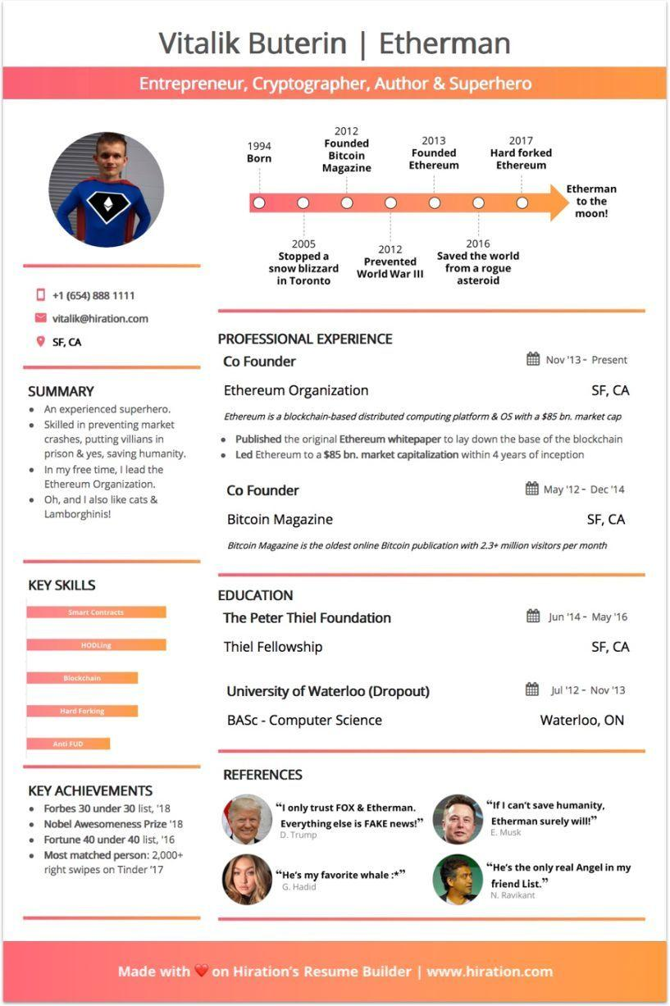
Vitalik Buterin | Etherman
Entrepreneur, Cryptographer, Author & Superhero
+1 (654) 888 1111
vitalik@hiration.com
SF, CA
2012
1994 Born
Founded Bitcoin Magazine
2013 Founded Ethereum
2017 Hard forked Ethereum
2005
Stopped a snow blizzard
in Toronto
2012 Prevented World War III
2016 Saved the world from a rogue asteroid
Etherman to the moon!
SUMMARY
• An experienced superhero. ⚫ Skilled in preventing market crashes, putting villians in prison & yes, saving humanity. In my free time, I lead the Ethereum Organization. Oh, and I also like cats & Lamborghinis!
PROFESSIONAL EXPERIENCE
Co Founder
Ethereum Organization
Nov '13- Present
SF, CA
Ethereum is a blockchain-based distributed computing platform & OS with a $85 bn. market cap
• Published the original Ethereum whitepaper to lay down the base of the blockchain • Led Ethereum to a $85 bn. market capitalization within 4 years of inception
Co Founder
Bitcoin Magazine
May '12-Dec '14
SF, CA
Bitcoin Magazine is the oldest online Bitcoin publication with 2.3+ million visitors per month
KEY SKILLS
Smart Contracts
HODLing
Blockchain
Hard Forking
EDUCATION
The Peter Thiel Foundation
Thiel Fellowship
University of Waterloo (Dropout)
BASC - Computer Science
Anti FUD
Jun '14 May '16
SF, CA
Jul '12 Nov '13
Waterloo, ON
KEY ACHIEVEMENTS • Forbes 30 under 30 list, '18 ⚫ Nobel Awesomeness Prize '18 • Fortune 40 under 40 list, '16 • Most matched person: 2,000+ right swipes on Tinder '17
REFERENCES
"I only trust FOX & Etherman. Everything else is FAKE news!" D. Trump
"He's my favorite whale:*" G. Hadid
"If I can't save humanity, Etherman surely will!" E. Musk
"He's the only real Angel in my friend List."
N. Ravikant
Made with on Hiration's Resume Builder | www.hiration.com

